Quantitative Trading Strategy for NIFTY 50 Using EMA Crossover and Machine Learning

Tej Raj  Department of Computer Science & Engineering  tej2461.be22@chitkara.edu.in | Shivam Laul  Department of Computer Science & Engineering  shivam824.be22@chitkara.edu.in | Avinash Kumar Jha  Department of Computer Science & Engineering  avinash200.be22@chitkara.edu.in | Dr. Shikha Tuteja  Associate Professor  Department of Computer Science & Engineering  Chitkara University Institute of Engineering and Technology  shikha.1290@chitkara.edu.in

Abstract— Quantitative trading has changed financial markets by replacing subjective decisions with data-driven strategies. However, traditional moving average crossover strategies often give false signals in sideways markets and do not adapt well to changing conditions. This paper presents a regime conscious quantitative trading model of the NIFTY 50 index to overcome these drawbacks. The suggested system uses a 5/15 Exponential Moving Average crossover system with a three-state Hidden Markov Model to classify market regimes between uptrend, sideways and downtrend phases. It harbors more than 86 features derived out of a single year of 5 minutes of OHLCV data, including technical indicators, Black-Scholes option Greeks, implied volatility statistics, and put-call ratios. XGBoost and LSTM classifier are trained to predict binary trade profitability. The full-period backtest has a profit factor of 3.40, Sharpe ratio of 4.182 and the maximum drawdown is confined to 0.81%. Outlier analysis demonstrates that only 1.65% of all trades carried out contribute to 26.99% of cumulative profits, and exceptional trades are the ones with high ATR and EMA gap values instead of the good entry conditions. From our results, it seems that trade management plays a bigger role than entry timing.
Keywords — Quantitative Trading, NIFTY 50, EMA Crossover, Hidden Markov Model, Regime Detection, Machine Learning, XGBoost, LSTM, Options Greeks, Backtesting.

1. INTRODUCTION
Over the last two decades, financial markets have changed significantly which was triggered by the widespread adoption of algorithmic and quantitative trading strategies. These methods replace intuition with systematic and rule-based approaches that are based on mathematical modeling and statistical inferences [1]. The NIFTY 50 index, which is a capitalization-weighted index of fifty blue-chip securities on the National Stock Exchange, in India, provides a liquid and well-defined tool that would best serve in the creation and testing of such strategies. The market participants have long used classical techniques of technical analysis, such as moving averages crossovers, to recognize trend reversal and possible entry points [2]. Even though these methods are popular, they have some clear limitations. One major issue is that they generate many false signals when in a state of consolidation, wherein frequent false crossovers destroy trading capital. Also, the common crossover strategies consider all signals equally; they lack the consideration of the current market environment and are unable to differentiate between a true trend breakout and a temporary variation within a range-bound stage. The recent breakthroughs in machine learning and statistical modeling have made the more adaptive trading structures accessible. In particular, Hidden Markov Models have shown significant potential in determining the latent order of financial time series, which consists of discrete regimes in the market that cannot be observed directly based on the price [3]. At the same time, gradient boosting models like XGBoost and recurrent models like Long Short-Term Memory networks have been used to forecast the directional performance of trades with different levels of effectiveness [4], [5]. In this paper, we propose a trading system which combines these strategies. The main component of the framework is a 5/15 EMA crossover strategy with a 3 state HMM-based regime filter that inhibits trading execution when in a sideways market. The system also includes more than 86 engineered features based on data of spot, futures, and options, and uses XGBoost and LSTM to predict the likelihood of an individual trade to be profitable. Lastly, stringent outlier analysis with Z-score techniques indicates that a small percentage of trades are causing the bulk of the returns, and that the high-impact trades can be identified by their volatility and momentum properties and not by entry level standards.
2. Literature Review
2.1. Technical Analysis and Moving Averages
Technical analysis assumes that past price and volume data can help predict future movements can be extracted and used to give information on future price actions [2].Various tools includes moving averages to filter the raw price data and identify the market trend. Exponential Moving Average The Exponential moving average gives decreasing weights to the older observations in an exponential manner and reacts faster to recent changes in the price than its simple counterpart. Mathematically, the EMA at time t is:
EMA_t = P_t × k + EMA_{t−1} × (1 − k)
where P t is the current price and (N + 1)/2) = k in a window of length N. The crossover strategy is a strategy that creates a buy signal when a short period EMA crosses over a longer period EMA and a sell signal when a long period EMA crosses over a short period EMA. Although simple to use, this mechanism is likely to produce too many signals in trendless settings which translate into frequent small losses that accumulate over time [6].

2.2. Hidden Markov Models in Finance
Hidden Markov Models (HMMs) are used to model sequences where the actual states are not directly visible that are used to model sequential data whereby the observed variables are believed to be produced by an underlying process the states of which cannot be directly observed [3]. HMMs have been used in the financial field to extract latent market regimes e.g. bull, bear and neutral regime based on observables of returns, volatility and volume measures. All the hidden states can be linked to emission distribution and the Baum-Welch algorithm can be applied to approximate the model parameters. The study by Hassan and Nath [7] showed the feasibility of HMM-based methods in stock price prediction, and later works were done to generalize the model to regime-conditional portfolio formation.
2.3. Machine Learning for Trade Prediction
Since the beginning of the 2000s, the use of machine learning in financial prediction has grown exponentially. XGBoost is proposed by Chen and Guestrin [4] and builds an ensemble of decision trees in a gradient-boosted, sequential fashion and uses L1 and L2 regularization to reduce overfitting. Its capacity to do mixed features types and missing values, coupled with computational efficiency, has been a good choice in tabular financial data. The vanishing gradient problem of standard recurrent neural networks by Hochreiter and Schmidhuber [5] is solved by constructing Long Short-Term Memory networks in which the flow of information is governed by gating mechanisms. This model works well for learning patterns in time-series data to learn temporal dependencies in high-frequency financial data, although again, its performance depends on whether enough training samples are available.
2.4. Options Greeks and the Black-Scholes Framework

The Black-Scholes model [8] is still a fundamental pricing instrument of European-style options and the calculation of sensitivities - also known as the Greeks. Delta is a measure of how the price of an option changes by one unit of the underlying, Gamma is the measure of the strength of the relationship between the underlying and the option, Theta is a measure of time-decay, and Vega is a measure of the sensitivity to the implied volatility. These measures in the context of a quantitative trading system can be viewed as informative features that describe expectations of market participants regarding future price dispersion and directional bias.

3. METHODOLOGY
3.1. Overall Architecture

The system is divided into six main parts: data acquisition, data cleaning, feature engineering, regime detection, strategy execution, and machine learning prediction. Data moves step-by-step through these stages, beginning with raw OHLCV records and culminating in trade signals that are evaluated through a comprehensive backtesting engine.

3.2. Data Pipeline

Three categories of market data are ingested: NIFTY 50 spot prices sampled at five-minute intervals (19,912 records spanning one calendar year), corresponding NIFTY futures data at the same frequency including open interest and contract rollover information, and NIFTY options data at hourly resolution covering at-the-money plus or minus two strike prices for both call and put sides (15,650 records). We handled missing values using forward-fill and removed outliers through forward-fill interpolation, removes obvious outliers, and aligns timestamps across all three data sources.

3.3. Feature Engineering

A total of 86 features are constructed, spanning several analytical categories. Six EMA-based indicators capture short-term momentum and medium-term trend, including the raw EMA(5) and EMA(15) values, their difference, crossover direction, and trend strength. Ten features are derived from Black-Scholes Greeks computed for at-the-money options: Delta, Gamma, Theta, Vega, and Rho for both call and put legs. Three implied volatility features—average IV, IV spread between calls and puts, and IV percentile rank—capture expectations of future price dispersion. Two put-call ratio features based on open interest and traded volume summarize directional sentiment. Additional derived features include Gamma Exposure, spot returns, and a futures basis measure that reflects the cost-of-carry relationship between spot and derivatives.

3.4. Regime Detection with Hidden Markov Models

The model is trained using the first 70 percent of the data and applied in the entire data. Each state is designated as Uptrend ( +1 ), Sideways (0 ) or Downtrend ( -1 ) after fitting depending on the average return in that state. The transition matrix that results shows that persistence is high, 98.5 percent in the case of Down trend, 70.7 percent in the case of Sideway, and 98.1 percent in the case of Uptrend, meaning that once a market has entered a specific regime, it is likely to stay in that regime.

3.5. Trading Strategy

The essence of the trading logic is as follows. A long position is called when EMA(5) crosses over EMA(15) and the present regime is deemed as Uptrend. The initiation of a short position occurs when the EMA(5) goes below the EMA(15) and the current regime is Downtrend. During Sideways times, no trade can be undertaken. The next opposite crossover signal is the time when exits occur.

3.6. Machine Learning Models

The machine learning aspect posits trade prediction as a binary classification problem: given the engineered features at the point of signal generation, whether the resulting trade will be profitable (label 1) or not (label 0). The data is comprised of 182 trade samples (70/30 training and testing) and the order of time is maintained to avoid data leakage. XGBoost will use a maximum tree depth of 6, a learning rate of 0.05, 200 boosting rounds, and five-fold time-series cross-validation. The LSTM model has a sequence length equal to 10 candles, a dropout regularization of 40 percent, and it has 128 units in a bi-directional layer and about 40,000 trainable parameters.

3.7. Machine Learning for Trade Filtering

The entire sample of 182 trades is divided 70/30 chronologically. XGBoost is set up with 200 estimators, a maximum depth of 6, a learning rate of 0.05, and fivefold walk-forward cross-validation. The LSTM uses a bidirectional network with 128 hidden units, length of input sequence of 10, dropout of 40 percent and has about 40,000 parameters.

4. Results and Discussion
4.1. Backtest Performance
The strategy is evaluated across three windows: a training period (first 70% of data), a testing period (remaining 30%), and the combined full period.
Table 1: Backtest Performance Metrics
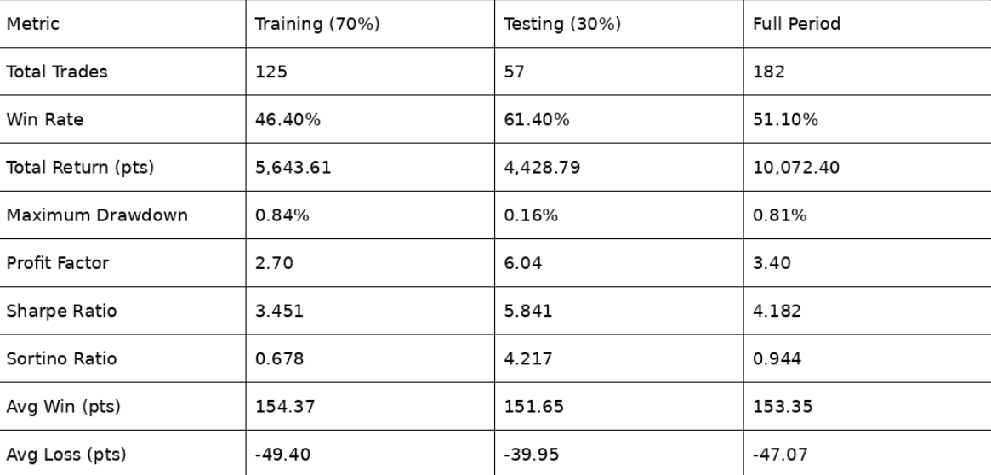
We observed that the testing period performs better than the training period the training window on nearly every risk-adjusted metric—the win rate improves from 46.40% to 61.40%, and the profit factor nearly doubles from 2.70 to 6.04. This suggests that the regime filter works well on new data and does not merely overfit to the historical data used for HMM training.
The equity curve shows a steady, upward-trending trajectory across the full period with shallow and short-lived drawdowns. The largest single drawdown of 892 points occurs during the training window around mid-2024 and is quickly recovered.
4.2. Trade Distribution Analysis
The trade results show a positive skew. The average trade return is 55.34 points, and the average winning trades are 153.35 points and the average losing trades are only -47.07 points, which return a good reward to risk ratio of about 3.26:1. The total of short positions create 6,845.79 points in 95 trades, whereas 3,226.61 points in 87 long trades. This is expected because market falls are usually sharper than rise that the decline in stock markets is normally more directional and intense compared to rises, which allows short-side investments to have higher returns per trade when the market is favorable.
4.3. Regime Analysis
The HMM identifies different patterns for each market regime. The Uptrend periods have large average spot returns and EMA momentum, whereas the Downtrend periods are marked with large implied volatility and broader IV spreads. The strategy completely avoids sideways regimes, which display compressed distributions on almost all features, in agreement with low-conviction, range-bound price action.

4.4. Machine Learning Model Performance
Table 2: Machine Learning Model Comparison
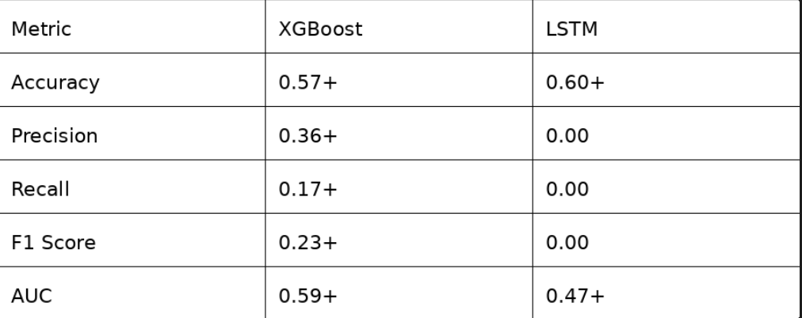
XGBoost shows limited prediction performance, with an AUC of 0.59, and few high-confidence predictions. The XGBoost model is very selective when used as a secondary filter on the top of the regime-aware crossover, rejecting around 99% of candidate signals, but with a 100% win record on the four trades that the model approves. This level of selectivity is not very practical, but proves that the model does capture some real signal.
The LSTM model, in its turn, predicts all samples as one sample, which means that the minority sample has a zero precision and a zero recall. This may be because the dataset is too small that the total number of samples (182) is too small to train a deep recurrent architecture of about 40,000 parameters, even with strong dropout regularization. This is in line with the larger literature indicating that deep learning models need considerably larger data to perform better than gradient-boosted tree models on structured tabular data [9].

4.5. Outlier Analysis and Statistical Testing
Three trades, representing just 1.65% of the total, are flagged as outliers using a Z-score threshold of 3. These three positions collectively contribute 2,718.87 points—26.99% of total cumulative profit—with an average gain of 906.29 points, which is 7.07 times the average return of the remaining profitable trades.
Table 3: Statictical Comparison: Outlier Vs Normal Profitable Trades
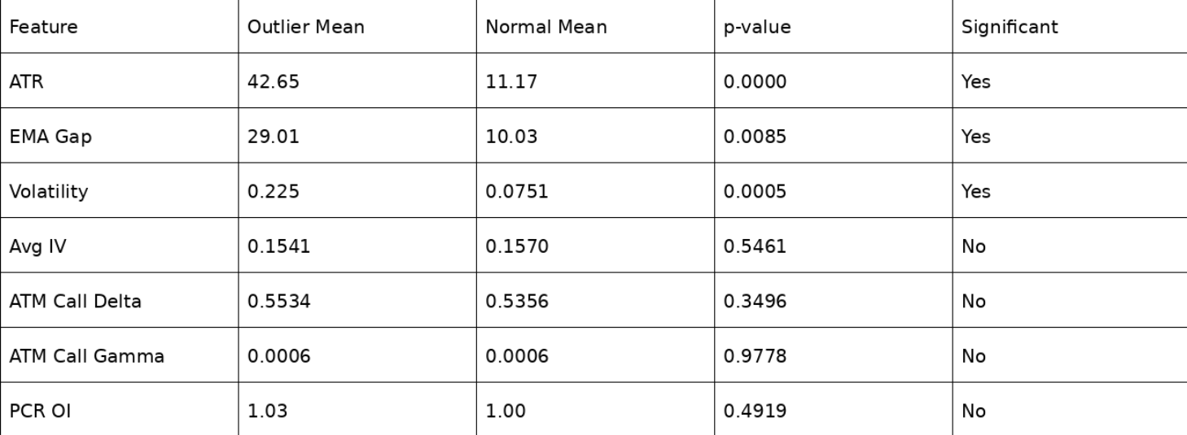
The results show a clear pattern. ATR, EMA gap, and realized volatility all show highly significant differences between outlier and normal profitable trades (p < 0.01 in each case). Outlier trades occur in environments where ATR is 3.8 times higher, the EMA gap is 2.9 times wider, and spot volatility is 3.0 times greater compared to typical winning trades. In sharp contrast, entry-level features such as implied volatility, Delta, Gamma, and PCR show no statistically significant difference whatsoever. This suggests that market conditions matter more than entry signals that it is the market environment and subsequent price movement—not the quality of the entry signal—that distinguishes exceptional trades from ordinary ones.
4.6. Time-of-Day Patterns
Analysis of trade entry times reveals a pronounced time-of-day effect. The mid-morning window from 10:15 to 12:00 yields the strongest performance, with a 70% win rate and an average per-trade profit of 79.09 points. The initial trading hour (9:15–10:15) captures the majority of trades (48.35%) but produces a lower win rate of 45.45%. Afternoon sessions from 12:00 onward show declining performance, with the last hour exhibiting both negative average returns and the lowest win rate of 11.11%.
6. CONCLUSION
In this paper, we introduced a trading system of NIFTY 50 index that combines exponential moving average crossover, Hidden Markov Model-based market regime classification and machine learning trade forecasting. The profit factor of the strategy is as high as 3.40, and the maximum drawdown is 0.81% in 182 trades over one year of 5-minute data. From the analysis, a few key points can be noted. First, regime filtering is efficient in the suppression of the false signal in the sideways markets as indicated by the strong out-of-sample generalization, the win rate increases by 46.40-61.40 in training and testing respectively. Second, a very small percentage of trades (1.65) produces a disproportionate amount of total profits (26.99), and the outlier trades are statistically differentiated by large values of ATR and EMA gap, not by options Greeks or implied volatility at entry. This shows that trade management is more important than entry timing, which permits positions to operate under the condition of high volatility trending, is of significant importance as compared to the entry selection. Third, XGBoost is more successful than LSTM in this problem context, in the first place, due to the insufficient size of the sample, 182 samples is not enough to train a deep recurrent network. Future research must include position sizing based on volatility (i.e. ATR-scaled lot size) to better exploit high-volatility regime periods, trailing stop-loss to protect gains built up during regime transitions, multi-instrument portfolio (to diversify risk), and real-time data feeds to deploy in real time and test. In future work, we plan to improve position sizing, add stop-loss strategies, and test the model on multiple instruments using real-time data.
7. REFERENCES
[1] E. Chan, *Quantitative Trading: How to Build Your Own Algorithmic Trading Business*, 2nd ed. Hoboken, NJ, USA: Wiley, 2021.
[2] J. J. Murphy, *Technical Analysis of the Financial Markets: A Comprehensive Guide to Trading Methods and Applications*. New York, NY, USA: New York Institute of Finance, 1999.
[3] L. R. Rabiner, "A tutorial on hidden Markov models and selected applications in speech recognition," *Proceedings of the IEEE*, vol. 77, no. 2, pp. 257–286, Feb. 1989.
[4] T. Chen and C. Guestrin, "XGBoost: A scalable tree boosting system," in *Proc. 22nd ACM SIGKDD Int. Conf. Knowledge Discovery and Data Mining*, San Francisco, CA, USA, 2016, pp. 785–794.
[5] S. Hochreiter and J. Schmidhuber, "Long short-term memory," *Neural Computation*, vol. 9, no. 8, pp. 1735–1780, Nov. 1997.
[6] B. G. Malkiel, *A Random Walk Down Wall Street*, 12th ed. New York, NY, USA: W. W. Norton, 2019.
[7] M. R. Hassan and B. Nath, "Stock market forecasting using hidden Markov model: a new approach," in *Proc. 5th Int. Conf. Intelligent Systems Design and Applications (ISDA)*, Wroclaw, Poland, 2005, pp. 192–196.
[8] F. Black and M. Scholes, "The pricing of options and corporate liabilities," *Journal of Political Economy*, vol. 81, no. 3, pp. 637–654, May–Jun. 1973.
[9] R. Shwartz-Ziv and A. Armon, "Tabular data: Deep learning is not all you need," *Information Fusion*, vol. 81, pp. 84–90, May 2022.
[10] M. M. Dacorogna, R. Gençay, U. A. Müller, R. B. Olsen, and O. V. Pictet, *An Introduction to High-Frequency Finance*. San Diego, CA, USA: Academic Press, 200
[11] J. Hull, Options, Futures, and Other Derivatives, 11th ed. Pearson, 2022.
[12] A. Fama, "Efficient Capital Markets: A Review of Theory and Empirical Work," Journal of Finance, vol. 25, no. 2, pp. 383–417, 1970.
[13] R. Tsay, Analysis of Financial Time Series, 3rd ed. Wiley, 2010.
[14] P. J. Brock, J. Lakonishok, and B. LeBaron, "Simple Technical Trading Rules and the Stochastic Properties of Stock Returns," Journal of Finance, vol. 47, no. 5, pp. 1731–1764, 1992.
[15] J. Welles Wilder, New Concepts in Technical Trading Systems. Trend Research, 1978.
[16] T. Bollerslev, "Generalized Autoregressive Conditional Heteroskedasticity," Journal of Econometrics, vol. 31, no. 3, pp. 307–327, 1986.
[17] R. Engle, "Autoregressive Conditional Heteroskedasticity with Estimates of Variance of UK Inflation," Econometrica, vol. 50, no. 4, pp. 987–1007, 1982.
[18] Y. LeCun, Y. Bengio, and G. Hinton, "Deep Learning," Nature, vol. 521, pp. 436–444, 2015.
[19] I. Goodfellow, Y. Bengio, and A. Courville, Deep Learning. MIT Press, 2016.
[20] Z. Zhang, S. Zohren, and S. Roberts, "Deep Learning for Portfolio Optimization," Journal of Financial Data Science, vol. 2, no. 4, pp. 8–20, 2020.
[21] B. Fischer and J. Krauss, "Deep Learning with Long Short-Term Memory Networks for Financial Market Predictions," European Journal of Operational Research, vol. 270, no. 2, pp. 654–669, 2018.
[22] H. Patel, S. Shah, P. Thakkar, and K. Kotecha, "Predicting Stock Market Index Using Fusion of Machine Learning Techniques," Expert Systems with Applications, vol. 42, no. 4, pp. 2162–2172, 2015.
[23] A. Shenfield, D. Day, and A. Ayesh, "Intelligent Trading Systems: A Review," Knowledge-Based Systems, vol. 124, pp. 32–41, 2017.

